Project Design Phase-II
Technology Stack (Architecture & Stack)

Date | 26 September 2026
Team ID | SWTID-2026-9376
Project Name | FitTrack AI – Personalized Fitness Recommendations Powered by AI
Maximum Marks | 4 Marks

Technical Architecture:
FitTrack AI is a backend-only application developed using Node.js and Express.js. The application exposes REST API endpoints that are tested using Thunder Client. Incoming requests are processed through routes, controllers, middleware, and service modules.
The backend handles user registration, login, profile access, JWT-based authentication, workout management, workout search, AI-generated workout recommendations, and fitness insights. bcrypt.js is used for secure password hashing, while JWT is used to protect authenticated routes.
Workout and user information are stored locally in MongoDB Community Server, with MongoDB Compass used to view and manage the database. Mongoose is used for schema definition, validation, and communication between the Node.js backend and MongoDB.
For AI-based fitness guidance, the backend communicates with the Google Gemini AI API. User details such as age, fitness goal, and experience level are sent to Gemini to generate personalized workout recommendations. Workout statistics such as total workouts, average workout duration, and calories burned are used to generate fitness insights.
The overall architecture connects the API client, backend application, local database, and Google Gemini AI service to process requests and return the required result as a JSON response.

AI WeatherWise Backend Technical Architecture

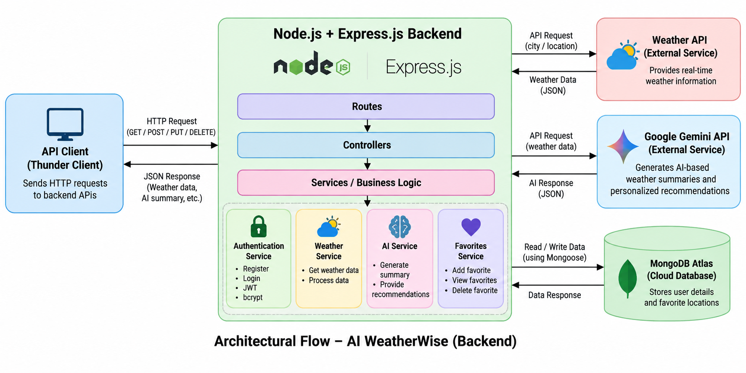 | Architecture Description:  - Backend Framework: FitTrack AI is developed using Node.js and Express.js.  - API Testing: REST API endpoints are tested using Thunder Client.  - Authentication: User registration and login are secured using JWT authentication and bcrypt.js password hashing.  - Profile Management: Authenticated users can view their profile information.  - Workout Management: Users can add, view, retrieve, update, and delete workout records.  - Workout Search: Users can search workout records using a search term.  - AI Service: Google Gemini AI generates personalized workout recommendations based on age, fitness goal, and experience level.  - Fitness Insights: Workout statistics are analyzed to generate fitness insights and improvement suggestions.  - Database: MongoDB Community Server stores user details and workout records locally.  - Database Interaction: Mongoose is used for schema definition, validation, and database operations.  - Database Management: MongoDB Compass is used to view and manage the local MongoDB database.  - Response: Processed user data, workout data, recommendations, and insights are returned to the API client in JSON format.

Table-1 : Components & Technologies:
S.No | Component | Description | Technology
 | API Interface | Backend APIs are accessed and tested through API requests without a frontend interface. | Thunder Client / REST API
 | Application Logic- Authentication | Handles registration, login, JWT generation, password verification, and protected routes. | Node.js, Express.js, JWT,bcrypt.js
 | Application Logic- Profile | Retrieves authenticated user profile information. | Node.js, Express.js
 | Application Logic- Workout Management | Handles adding, viewing, retrieving, updating, and deleting workout records. | Node.js, Express.js
 | Application Logic- Workout Search | Searches workout records using a query parameter. | Node.js, Express.js
 | Application Logic- AI Service | Generates personalized workout recommendations and fitness insights. | Google Gemini AI API
 | Data Base | Stores registered user information and workout records. | MongoDB Community Server, Mongoose
 | Database Management | Used to view and manage the local MongoDB database. | MongoDB Compass
 | File / Configuration Storage | Stores source code and configuration files during development. | Local File System / .env
 | External API | Provides AI-based workout recommendations and fitness insights. | Google Gemini AI API
 | Security | Protects passwords, private routes, JWT secrets, and API keys. | bcrypt, JWT, Environment variables
 | Infrastructure | Runs the backend application locally and connects with MongoDB and Gemini AI. | Node.js Local Server

Table-2: Application Characteristics:
S.No | Characteristics | Description | Technology
 | Open-Source Frameworks | The backend uses open-source technologies for API development and database interactions. | Node.js, Express.js, Mongoose
 | Security Implementations | Passwords are hashed before storage, JWT protects private routes, and sensitive keys are stored in environment variables. | bcrypt.js, JWT, .env
 | Scalable Architecture | Routes, controllers, models, middleware, and services are separated so new features can be added easily. | Modular Node.js / Express.js Architecture
 | Availability | The backend is available while the Node.js server and local MongoDB service are running. Gemini AI features require internet connectivity. | Node.js, MongoDB Community Server, Gemini API
 | Performance | API requests and database operations are processed efficiently for authentication, workout management, search, and AI-based requests. | Node.js, Express.js, Mongoose
 | Maintainability | Modular project structure makes the application easier to understand, debug, update, and extend. | Routes, Controllers, Models, Middleware, Services

